**Academic Session-**

Academic and session module will consist the data of different Academic year. On clicking Academic session on user profile, you can search the data of any year. For Ex. If you search the academic year 2018-2019 the dashboard of NetCampus will according to the year that you have search.

Below picture show the front screen of the Session & Academic Year-

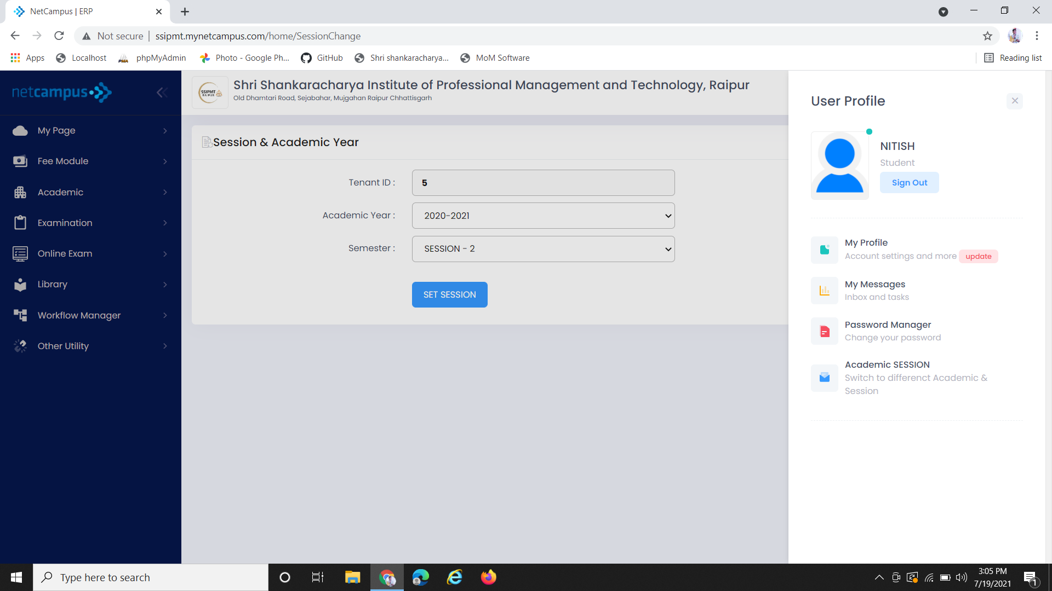

After setting the Academic year and semester Click on Set Session button. Then the dashboard will give detail of that year.

By this dropdown you can set the semester i.e. session 1 or 2

By this dropdown you can change the Academic year